**Report for HCI Lab2**

Quan Deng

School of Software Engineering

Tongji University

Shanghai,China, E-mail

[1953871@tongji.edu.cn](mailto:1953871@tongji.edu.cn)

**Task 1. Describe the requirements of an image search task**

* First, we need to prepare a sufficient number of images that have been classified as a database for searching.
* Then, there should be an interface that can interact well with the user, which can be a web page, app, applet, etc.
* On these interfaces, there should be an area for the user to upload the image he wants to search, the user should be able to preview the image he wants to search, and after that there should be a search button to submit this search.
* It should tell the user in time whether the search is successful or unsuccessful and what the number is when the search is successful. The search results should be displayed uniformly in the form of a list and tell the user what keywords are searched for and provide the function of filtering by keywords.
* For each search result, it should be possible to provide functions such as collection and download.

**Task 2. Show your designs for five stages and give a brief description for features that you implement**

**Stage 1. Formulation**

**It contains an input box to upload an image.**

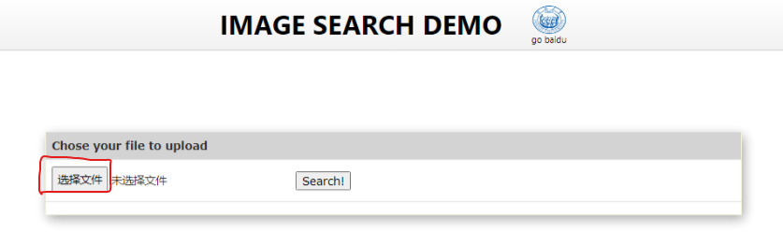

**Users can preview the query image in the searching window.**

Users can click "Select File" to select the image to be searched, click "Search!" on the right side of the search bar to submit an image for search, and display the image uploaded by the user at the bottom of the search bar.

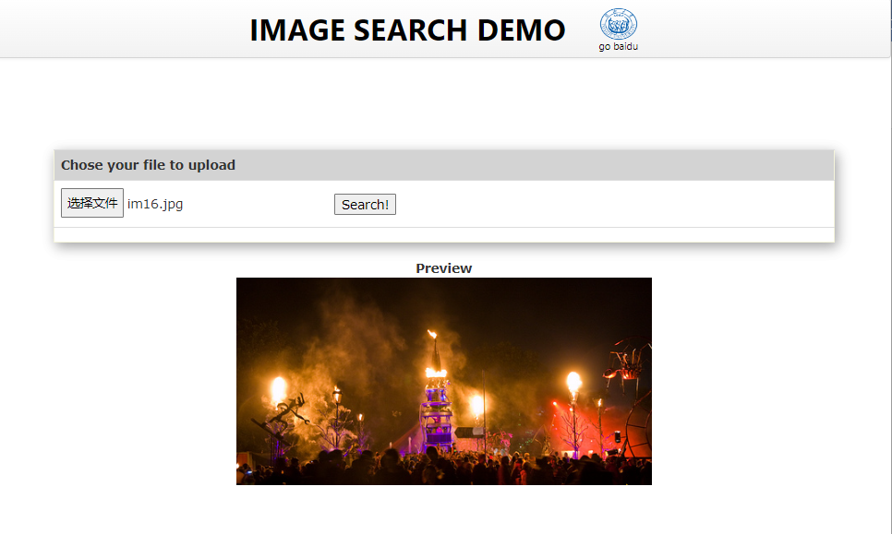

**Stage 2. Initiation**

**It has a search button.**

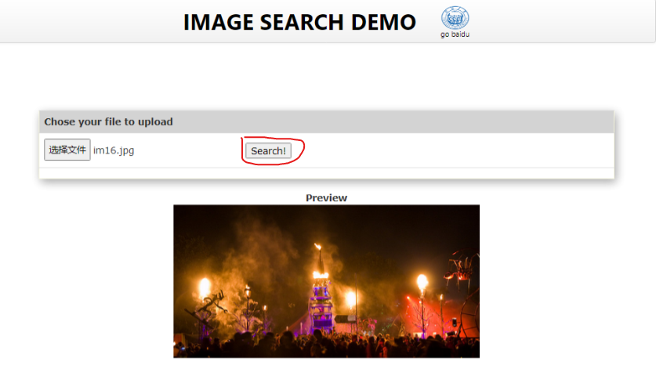

During the execution in the background of the system, the user will experience a waiting period. By displaying a spinning circle on the interface and the text "waiting..." to characterize this period.

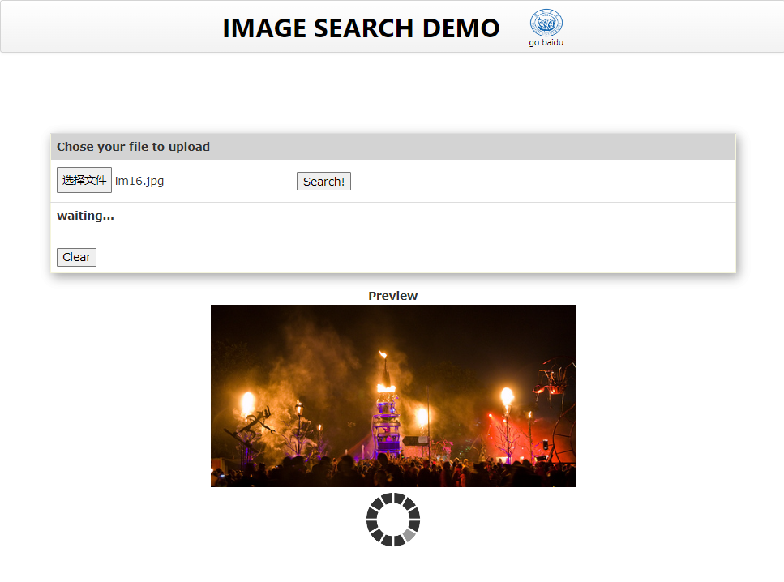

If no image is selected, click the Search button, and the following prompt will be displayed.

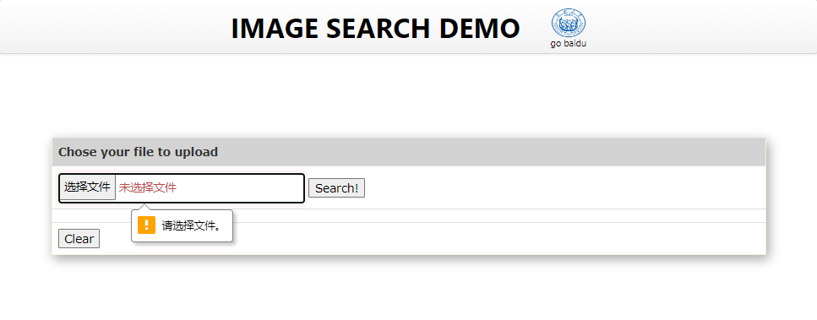

**Stage 3. Review**

**The whole result display page is as follows.**

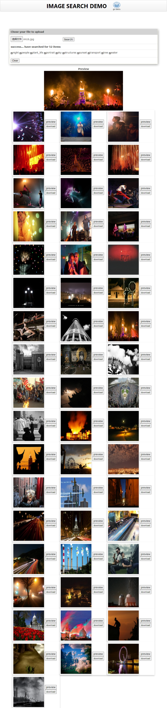

**Provide an overview of the results.**

At the bottom of the search bar, the total number of searched entries and tags are displayed.

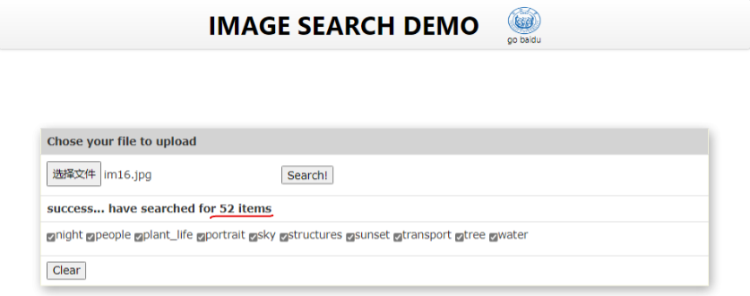

The search results will be displayed in the form of a list.

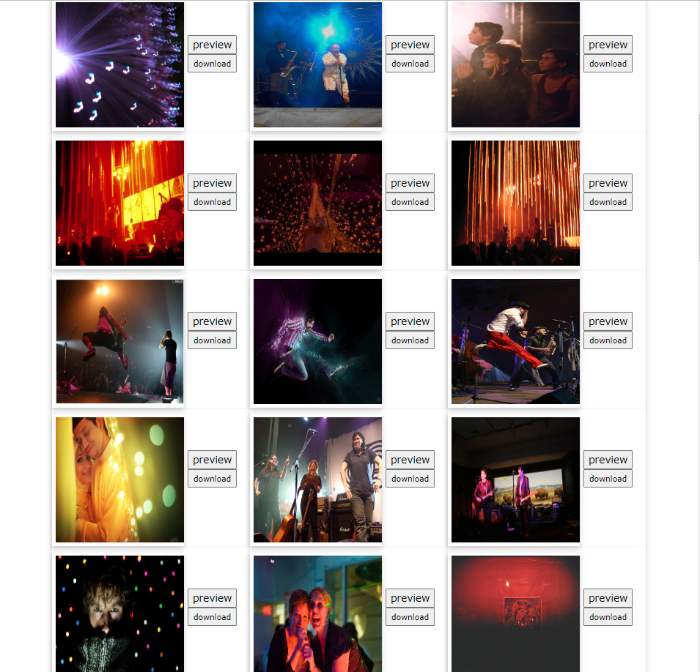

**Stage 4. Refinement**

**Allow changing search parameters when reviewing results.**

Users can choose which search results to show or hide by selecting certain category/tag in the tab bar.

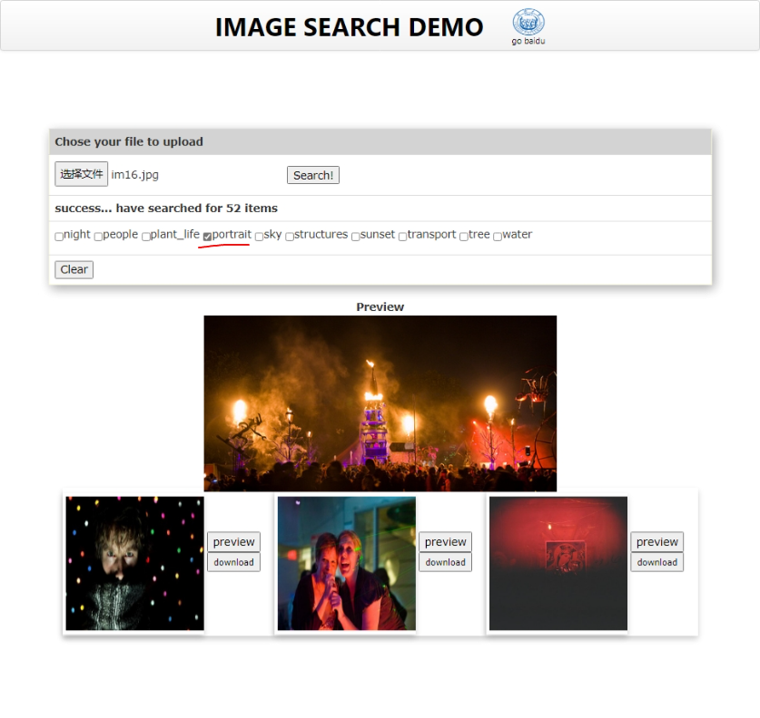

**Stage 5. Use**

**Users can take some actions**, such as previewing or downloading.

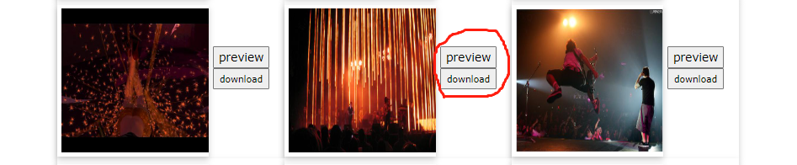

Clicking on the preview will show it on the web page, and users can see a clearer larger image.

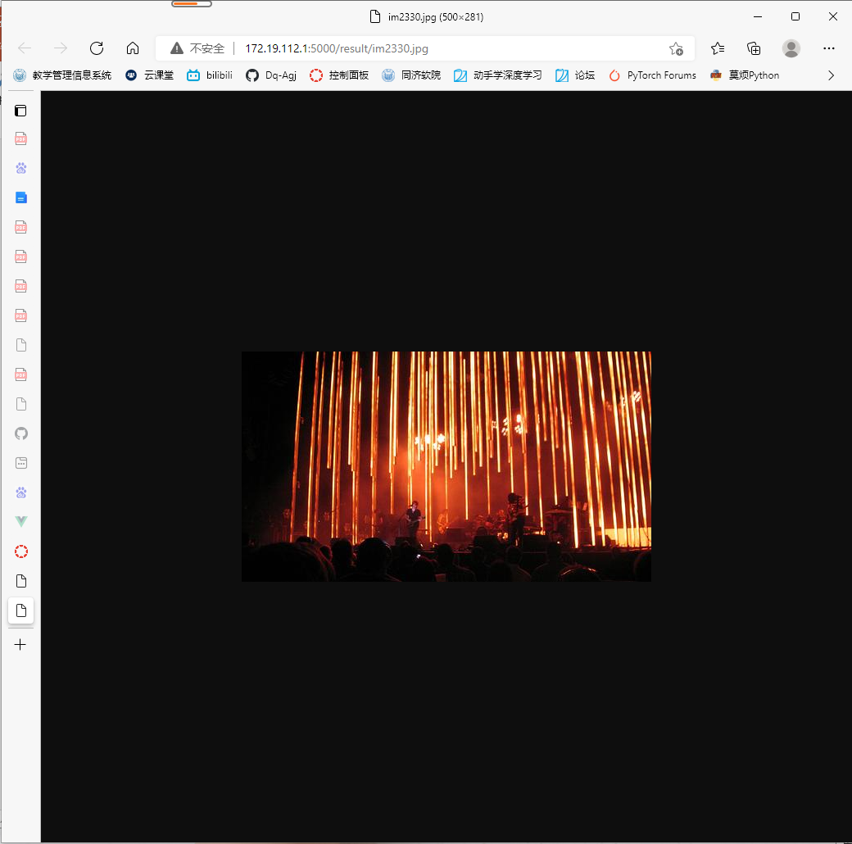

Click to download the image and save it to your local area.

